Mr Furballski:

I’m excited to share with you two designs of mockup for your new website.

As a loyal customer of Donut Delights myself, I understand that your store needs to design a website to ensure existing long-time customers are kept and new ones are converted. This new website will reflect a warm, fun and approachable donut & coffee shop with brand values of trust and quality. Except the traditional homepage, menu page and about us page, the website will include a contact page for customers to contact the store, join the newsletter club and find locations. In addition, this design will embrace the newly emerging responsive web design (RWD) idea, which is an approach aimed at allowing desktop webpages to be viewed in mobile devices.

###### Two designs:

To target different audience, I present two options of design for Donut Delights. One family-oriented design is trying to appeal more general demographics by graphic and interactive design, and the other with simple bright color theme (pink and orange) and quick information is built for younger customers who tend to have shorter attention. I will explain the first design in more detail.

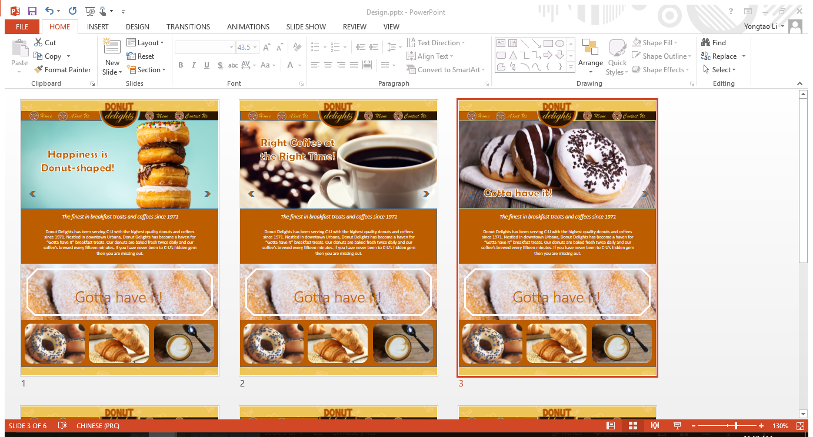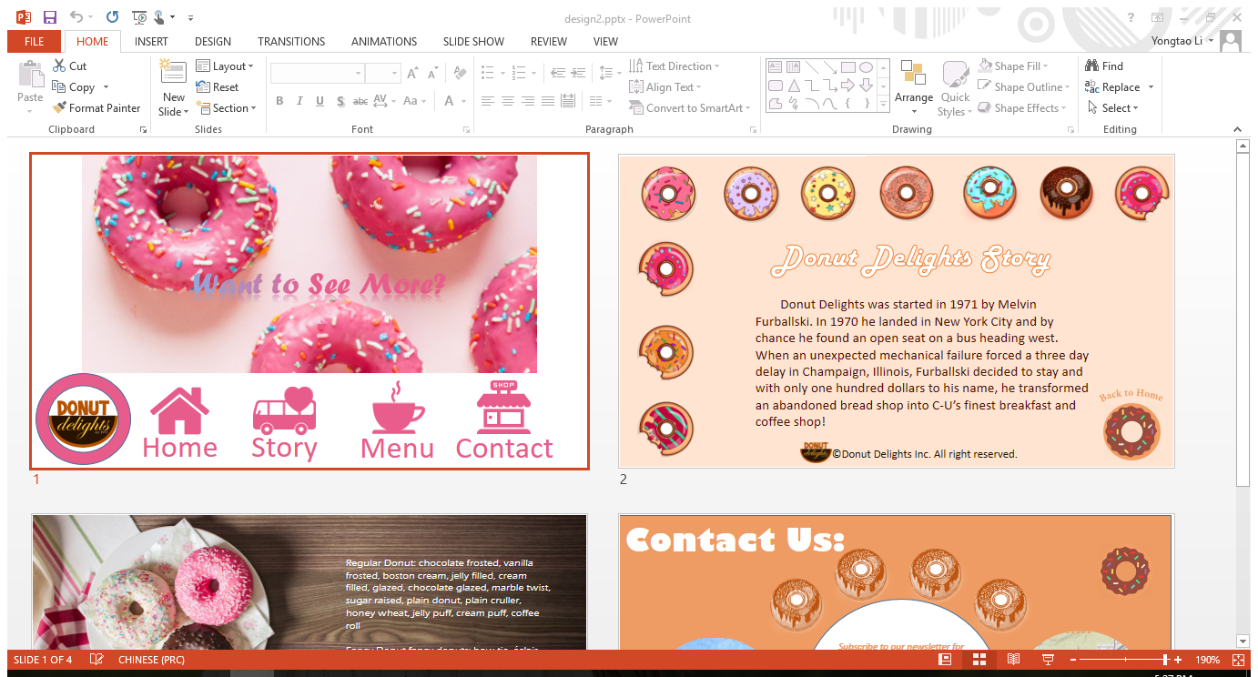

###### Home page:

The first design picked the light brown and dark brown from the store logo as its accent color, because they’re reminding people of coffee, chocolate and other warm, sweet things. And a carousel of color-rich, full-width images with a clean simple font welcomes everyone on the homepage and implores him/her to stay. As the name “Donut Delights” signified, this store is about donut, so the main slogan I created for this campaign is “Happiness is Donut-shaped” which is displayed next to eye-catching, mouth-watering image.

###### About us

I’m personally touched and inspired by your success story and I found a graphic way to present it to people: adding a “donut map” and landmark photos demonstrating the three places that meant a lot to you and this shop. This map and the three clocks are definitely going to capture people’s attention and add some humor and fan to this site.

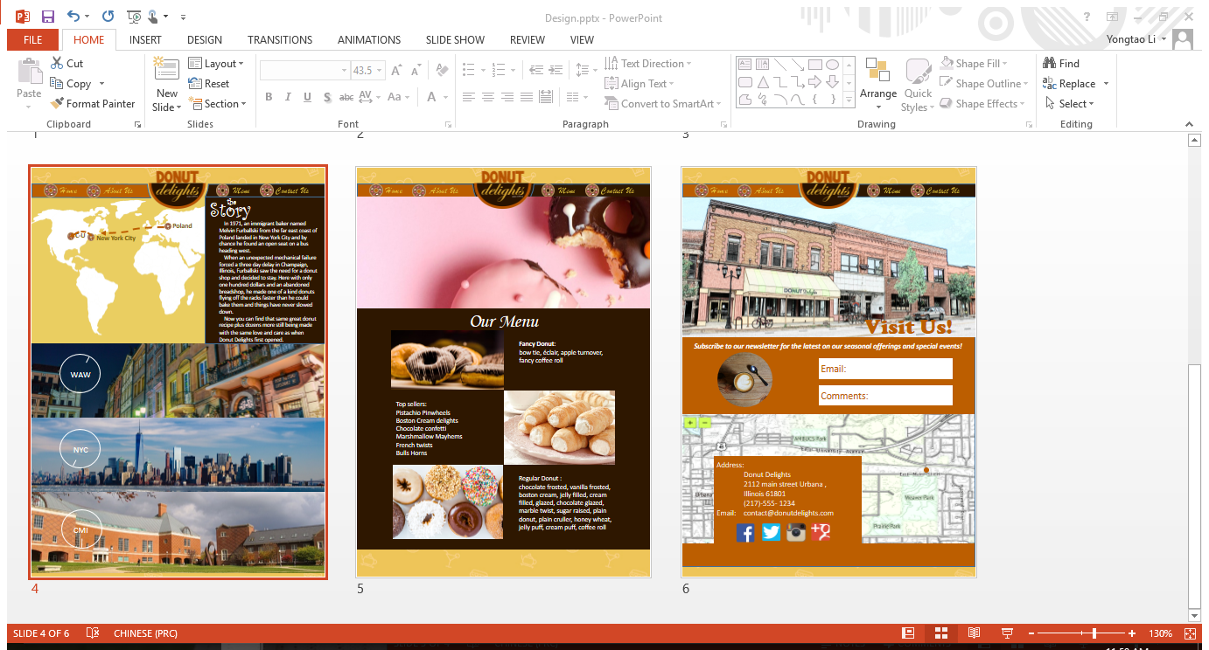

###### Menu

A single-colored dark brown background lets the product images take center stage. The above picture has a bright pink color contrasted with dark background. Below that picture, the menu page splits its site with bilateral symmetry, with one side for products and the other for descriptions.

###### Contact us

Sometimes less is more. This page features a big store front photo (I recolored it to a pencil drawing). And the comment area and map area remain a timeless back-to-basics theme: a clean map and bold font.

Interaction

To engage audience interacting with this website, I will include some mouse-hover effects and transition animation.

###### Additional must-have:

* A Form for getting customer email for online promotions and special events.
* Social Media Links: Facebook, Google+, Instagram, twitter.
* Fun donut and coffee facts, jokes: the donut map☺
* Famous artwork that features donuts or coffee as filler: a color pencil drawing of the store front photo.

I’m truly excited to be working with you on your new website design. Looking forward to hearing from you soon.

Bryna Zhao

2016/11/12